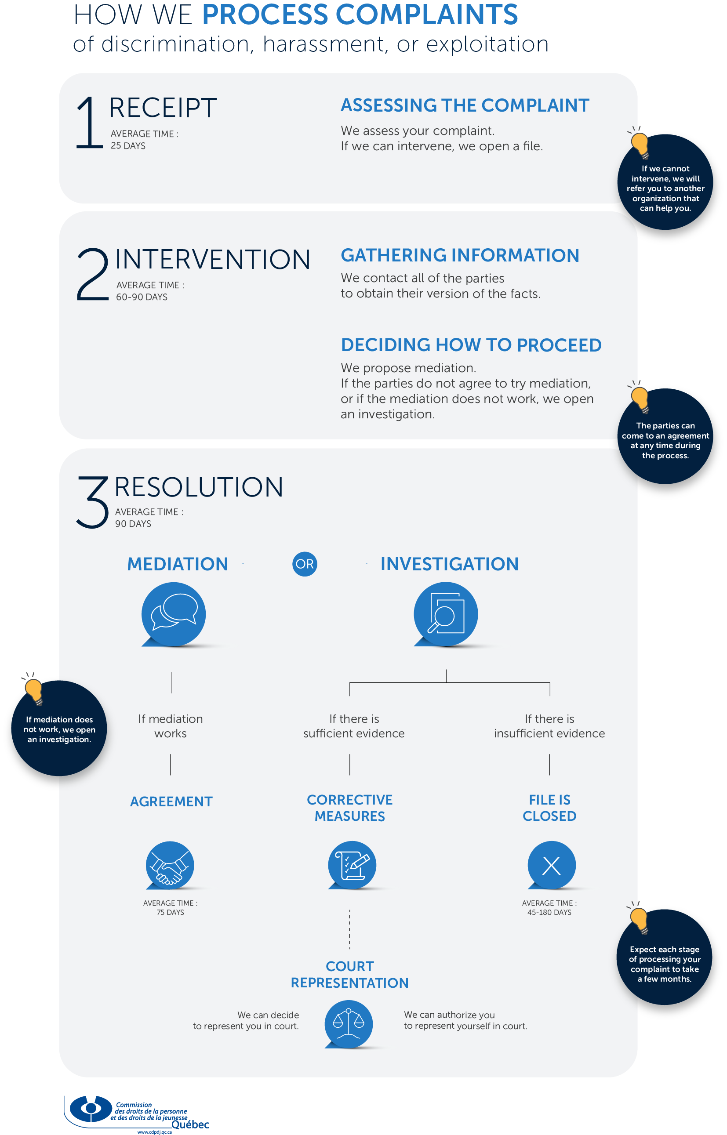

How we process complaints
of discrimination, harassment, or exploitation

To file a complaint, please complete the online complaint form at plainte.cdpdj.qc.ca/en.
If you need help filling out the form, email us at plainte@cdpdj.qc.ca or call 1 800 361-6477.

Receipt

Assessing the complaint
- An intake and evaluation technician opens a file and assesses whether your complaint is 'admissible', meaning that the Commission can process it. This person might contact you for more information.
- If the Commission cannot intervene in your complaint, we will refer you to an organization that can, like the Commission des normes, de l'équité, de la santé et de la sécurité du travail, the Tribunal administratif du logement, your union, etc.

2. Intervention

Gathering information
An evaluation advisor:
- contacts you to clarify the details of your complaint and to make sure that nothing is missing
- contacts the respondent to let them know that a complaint has been filed against them
- finds out if you and the respondent (the 'parties') are open to settling the case out of court, through mediation.
Gathering information is the first step in our investigation

DECIDING how to proceed
- If the parties agree to try mediation, your file is transferred to a mediator.
- If the parties refuse mediation, the investigation may continue.
- At this stage, the Commission may decide not to intervene in your case. This could happen for several reasons, for example, if you have already taken the matter to court, or if you filed the complaint after the legal time limit for doing so. Your file will then be closed. (Learn more about the Commission’s reasons for closing a file).

Resolution

Mediation
- Mediation takes place only if both parties (you and the respondent) agree to it.
- A mediator will contact you and the respondent. Then, the mediator will meet with you both to help you find common ground.
  - If you can reach an agreement, the mediation worked. In that case, a memorandum of agreement is prepared and signed by both parties. The complaint is now resolved, and the file will be closed.
  - If you cannot agree, the mediation didn’t work. In that case, the file will be transferred to an investigator.

Investigation
An investigation takes place only if the parties (you and the respondent) did not wish to try mediation or if you could not reach an agreement during mediation.

Gathering evidence
- An investigator gathers evidence about the complaint (documents, audio or video recordings, testimony, etc.). The investigator’s role is to determine whether there is sufficient evidence to support the claims in your complaint.
- At any point during the investigation, you and the respondent can settle the case on your own by coming to an agreement.

The Complaints Committee’s decision
- The investigator submits a report to the Complaints Committee. This committee is made up of three members of the Commission.
- The Complaints Committee assesses whether there is sufficient evidence to support the complaint, and then makes a decision.

Sufficient evidence | Proposal for corrective measures
- If the Complaints Committee finds that there is sufficient evidence to support your complaint, it can propose various corrective measures to the respondent.
- The respondent will be given a deadline for implementing the corrective measures.
- Once the respondent has implemented the corrective measures, your file will be closed.
- If the respondent does not implement the corrective measures, the Complaints Committee can ask the Commission to take the matter to court on your behalf.

Sufficient evidence | Decision to represent you in court
- If the respondent does not implement the corrective measures that the Complaints Committee has proposed, the Commission can take the matter to the Human Rights Tribunal to request appropriate action on your behalf. In this case, a lawyer from the Commission will represent you before the Tribunal, free of charge.

Sufficient evidence | Decision not to represent you in court
- Sometimes, even if there is sufficient evidence to support your complaint, the Complaints Committee may decide not to ask the Commission to represent you at the Human Rights Tribunal. This could be the case, for example, if your dispute does not raise any complex questions of fact or law. The Commission assesses each case in light of the particular circumstances of the file. (Learn more about the Commission’s reasons for closing a file).
- The Commission sends the parties a letter to inform them of this decision. This letter includes the supporting evidence that we have gathered, so that you can use it if you decide to take the case to court yourself.
- Even if the Commission closes your file, you can initiate a claim with the Human Rights Tribunal at your own expense. To do this, you have 90 days from the date when you received notice from the Commission that your file was closed. This limitation period is known under Québec law as a prescription.

Insufficient evidence | Decision to close your file
- If the Complaints Committee finds that there is insufficient evidence to support your complaint, the Commission 'ceases to act', meaning that we close your file.
- The Commission sends the parties a letter to inform them of this decision.
- Even if the Commission closes your file, you can initiate a claim with the civil courts (e.g., the Superior Court or the Small Claims Division or another division of the Court of Québec), at your own expense.

Who handles your complaint?
You will communicate with various people at the Commission while your complaint is being processed. Each person has a unique and important role in handling your complaint.

Office clerk
This person responds to requests for information and helps people file complaints with the Commission. They keep files up-to-date by adding any relevant documents.

Intake and evaluation technician
This person analyzes complaints using the criteria set out in the Charter of Human Rights and Freedoms and opens an investigation file if the complaint is admissible.

Evaluation advisor
This person contacts the parties to gather more information about the complaint, to get the respondent’s version of events, and to suggest mediation.

Mediator
This person meets with the parties to help them resolve their dispute outside of court.
Learn more about mediation.

Investigator
This person gathers evidence and submits an investigative report to the Complaints Committee for a decision. Learn more about investigations.

Complaints Committee
This committee, made up of three Commission members, makes decisions based on the results of the investigation into your complaint.

Lawyer
This person represents you at the Human Rights Tribunal at the request of the Complaints Committee. Learn more about court representation.

